AI Assisted Coding
Assignment 14.3
Name: V.Tharun varma
RollNo: 2303A52265
Batch: 45 Task-1:
Scenario
A student wants to showcase academic projects, technical skills, and contact information through a personal portfolio website. AI tools are used to speed up development while maintaining quality and customization.
Tasks
- Use GitHub Copilot to generate a semantic HTML structure with sections: o Home o About o Projects o Contact
- Ask Copilot to suggest responsive CSS using Flexbox or Grid.
- Customize AI-generated CSS to add:
o Hover effects on project cards o Smooth scrolling navigation
Expected Outcome
- Clean and well-structured portfolio website
- Responsive layout for desktop and mobile screens
- Interactive project cards

Output:
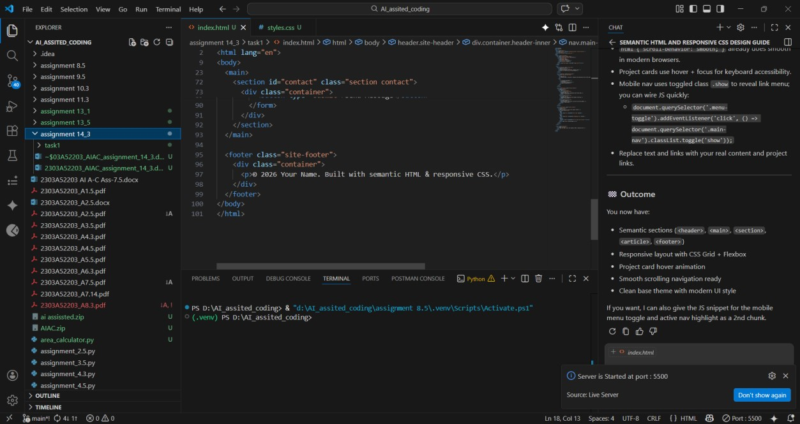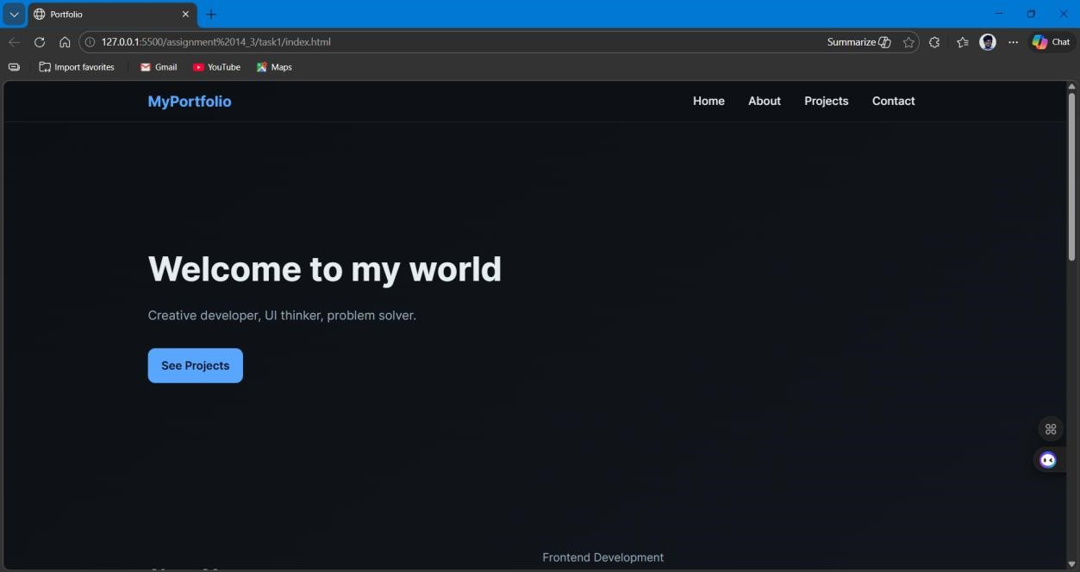

Task-2:
Scenario
A local restaurant requires a simple yet attractive landing page to display its offerings. The developer uses AI assistance to rapidly generate UI components.
Tasks
1. Use Copilot to create a navigation bar with links:
o Home o Menu o Gallery o Contact
- Generate a menu section styled with CSS cards.
- Implement a JavaScript-based image slider for the gallery using Copilot suggestions.
- Customize animations or transitions for better user experience.
Expected Outcome
- Fully functional restaurant landing page
- Responsive navigation bar
- Working image slider with smooth transitions
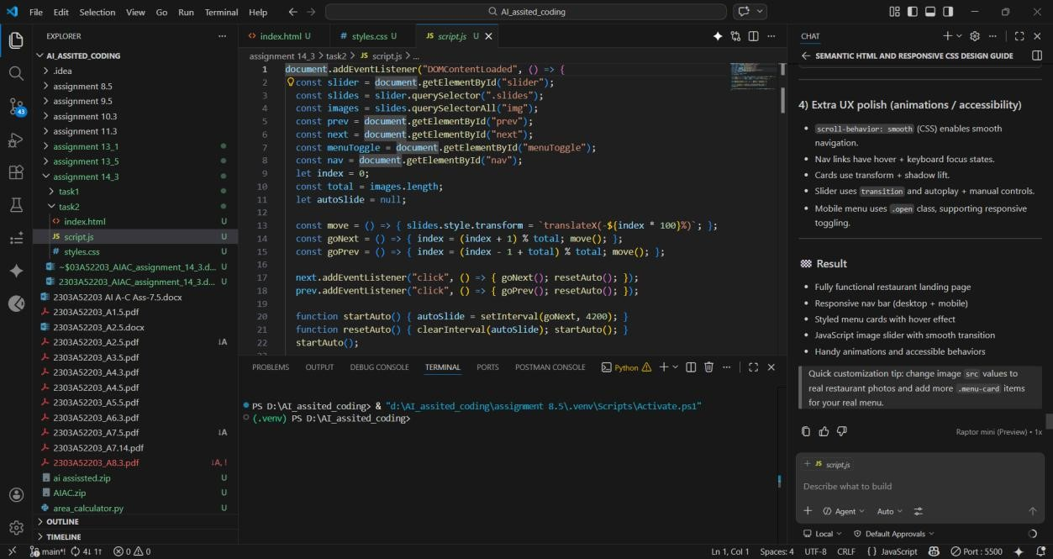
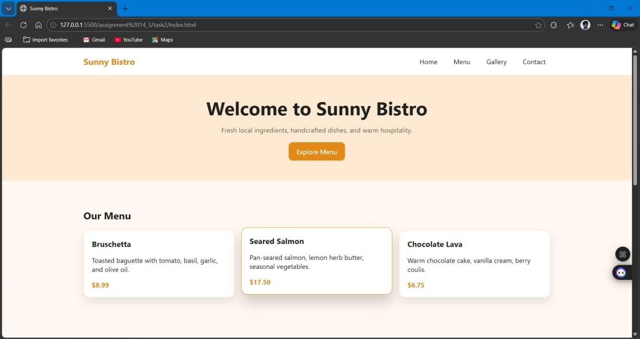
Task 3: AI-Powered Event Registration Form
Scenario
SR University is hosting a technical fest and requires an online registration form with real-time validation to ensure accurate user input.
Tasks
1. Ask Copilot to generate an HTML form with the following fields:
o Name o Email o Phone Number o Department o Event Selection
- Use AI assistance to style the form using CSS for readability and accessibility.
- Implement JavaScript validation using Copilot: o Email format validation o Phone number length validation o Required field checks Expected Outcome
- User-friendly and visually appealing form
- Real-time validation messages
- Prevention of invalid submissions
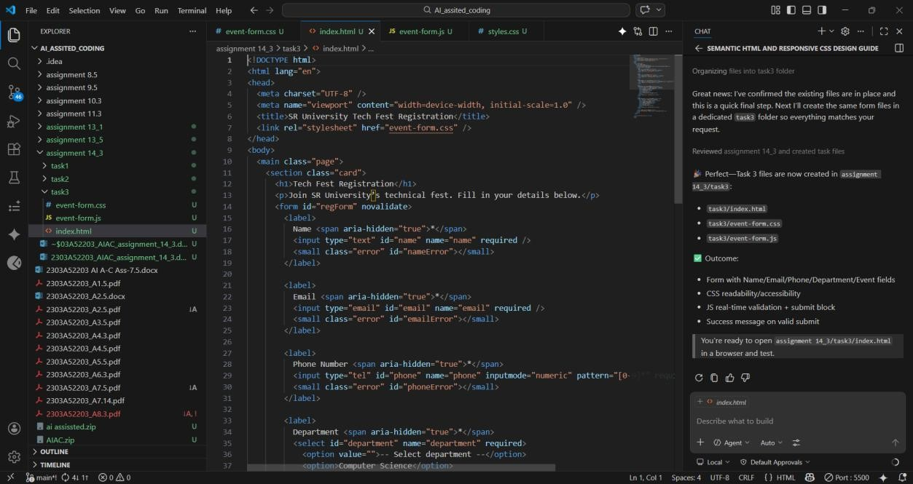

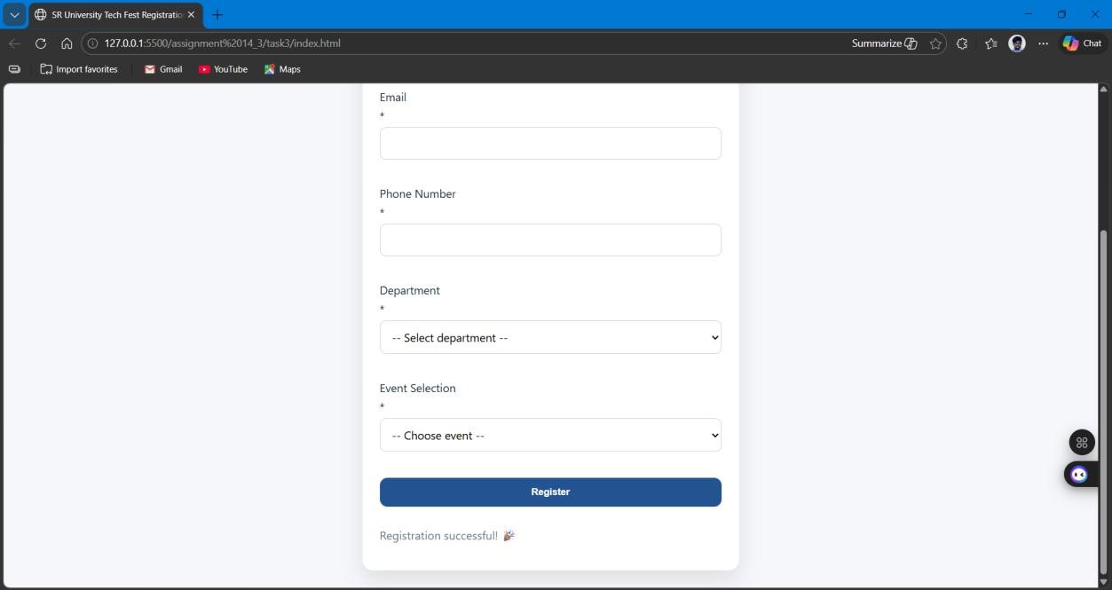

Task 4: AI-Assisted E-Commerce Product Page
Scenario
A startup is developing a basic e-commerce product page to showcase products and manage simple cart functionality.
Tasks
- Use Copilot to generate a grid-based product catalog using HTML and CSS.
- Implement an “Add to Cart” feature using JavaScript.
- Modify AI-generated code to include: o Cart item counter at the top-right corner o Visual feedback when a product is added
Expected Outcome
- Functional product catalog • Working cart counter
- Interactive user experience

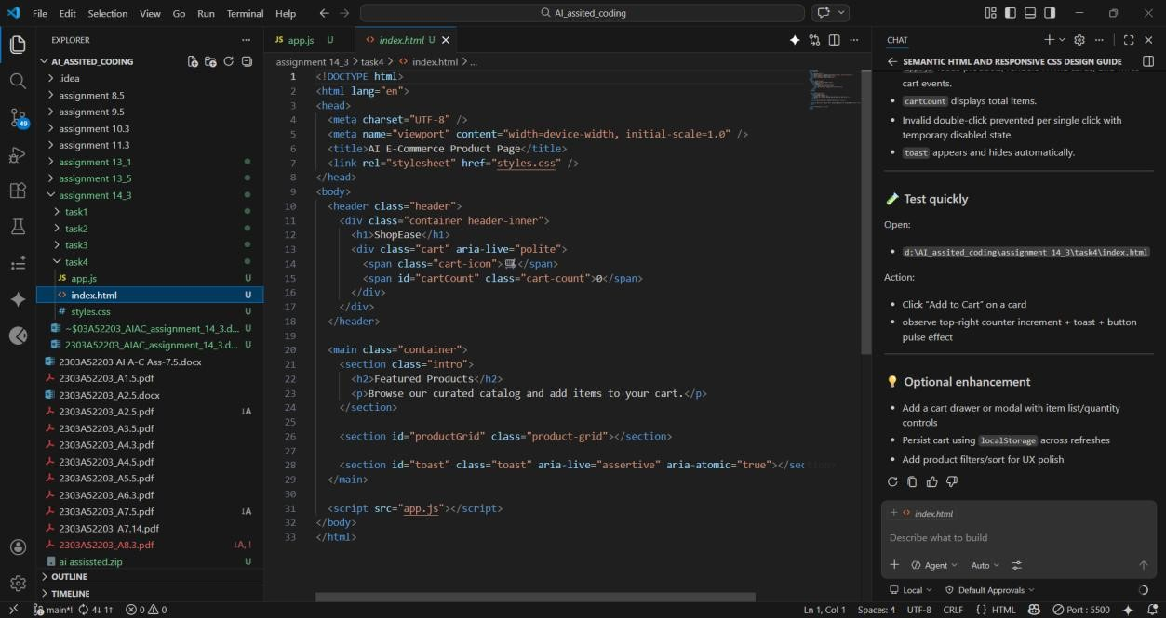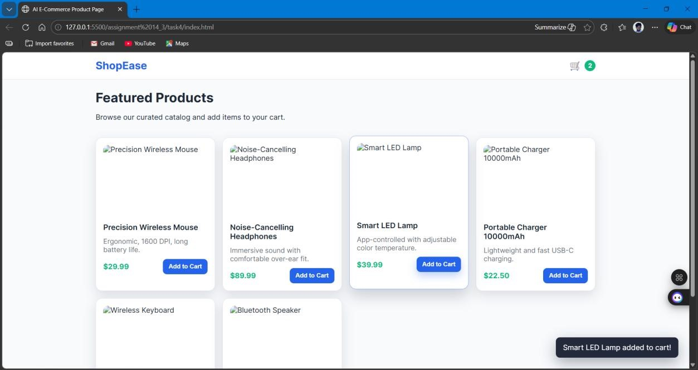

Task 5: Create a Responsive Web Page Layout Instructions:
- Design a basic web page layout with a header, main content area, and footer using HTML and CSS.
- Use AI to assist in generating responsive CSS for different screen sizes.
- Ensure the layout is clean and visually organized.
Expected Output:
- A responsive web page with:
- Header with navigation links
- Main section with placeholder text/images
- Footer with copyright or contact info
- Layout adapts correctly to desktop, tablet, and mobile screen sizes.
